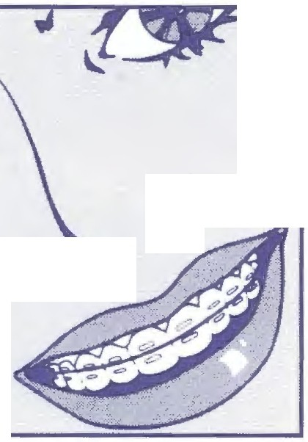IOUIS C. f lLIPPONE, D.D.S., P.C.

L O R T H O D O N=
T I Sa T

CENTREVILLE (703) 815-0127
GAINESVILLE (703) 754-4880

THE ORTHODONTIC DIET - PROHIBITED FOODS

No candy of any kind. The only exception is thin, plain, chocolate. No gum of any kind. Not even sugarless or gum for "dental work". Nothing hard, sticky, or chewy is allowed. Examples:

Nuts Popcorn Bagels Pizza crust
Hard pretzels Raw vegetables Raisins
Hard tacos Croutons
Doritos or other chips Hard Bread or rolls Hard cookies Jerky/Slim Jims Crunchy cereal Granola bars
Fruit Rollups/otber chewy fruit snacks Apples or like fruit (cooked/cut up)
Ice in drinks only (DO NOT CHEW ON ICE)

Foods that must be bitten off are not allowed. Examples:

Ribs Chicken Pork chops
Steak on the bone Com on the cob

(note: cut these or similarfoods off the bone or cob)

Do not chew on pens, pencils or fingernails Limit sugar intake and soft drinks.

